**IAM User Assignment**

**(Shreyas Umesh Bhinge)**

**Problem Statement:**

You work for XYZ Corporation. To maintain the security of the AWS account and the resources you have been asked to implement a solution that can help easily recognize and monitor the different users.

Tasks To Be Performed:

1. Create 4 IAM users named “Dev1”, “Dev2”, “Test1”, and “Test2”.

2. Create 2 groups named “Dev Team” and “Ops Team”.

3. Add Dev1 and Dev2 to the Dev Team.

4. Add Dev1, Test1 and Test2 to the Ops Team.

1. **Create 4 IAM users named “Dev1”, “Dev2”, “Test1”, and “Test2”.**

1. Click Create User

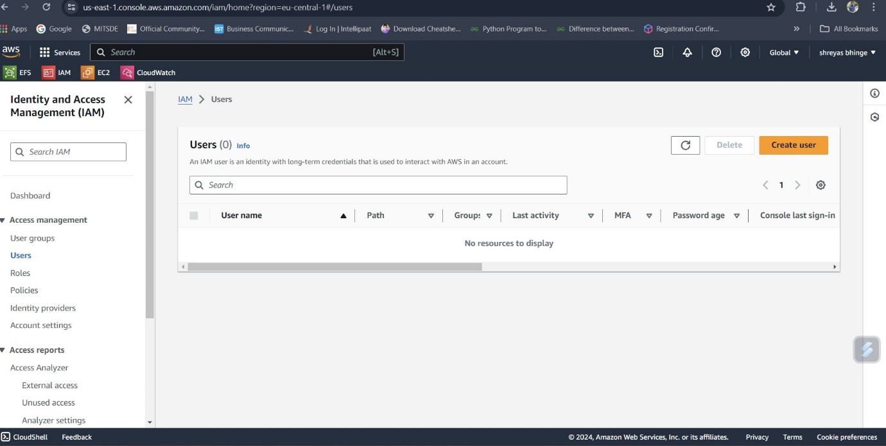

1. Specifing user details

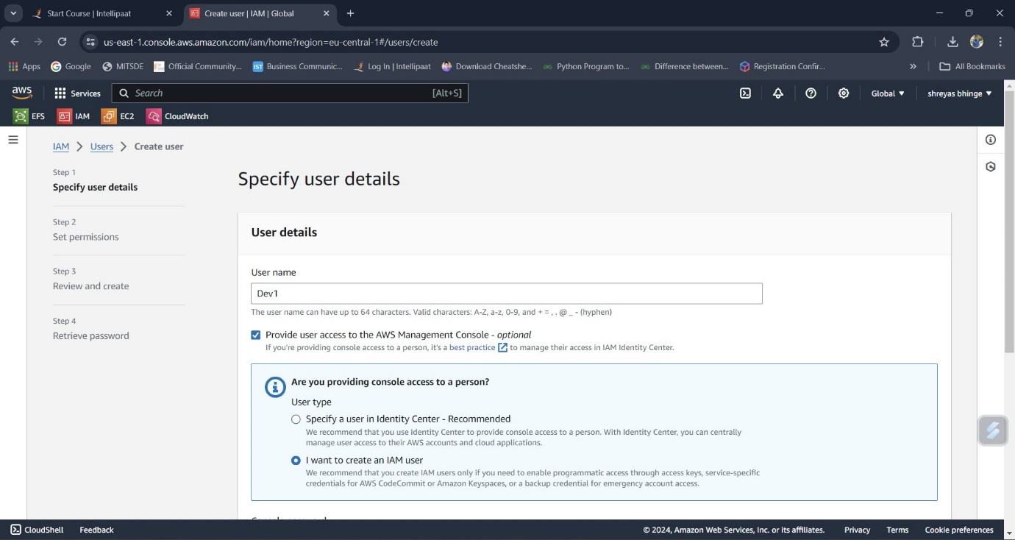

1. Created 4 user Dev1,Dev2,User1,User2

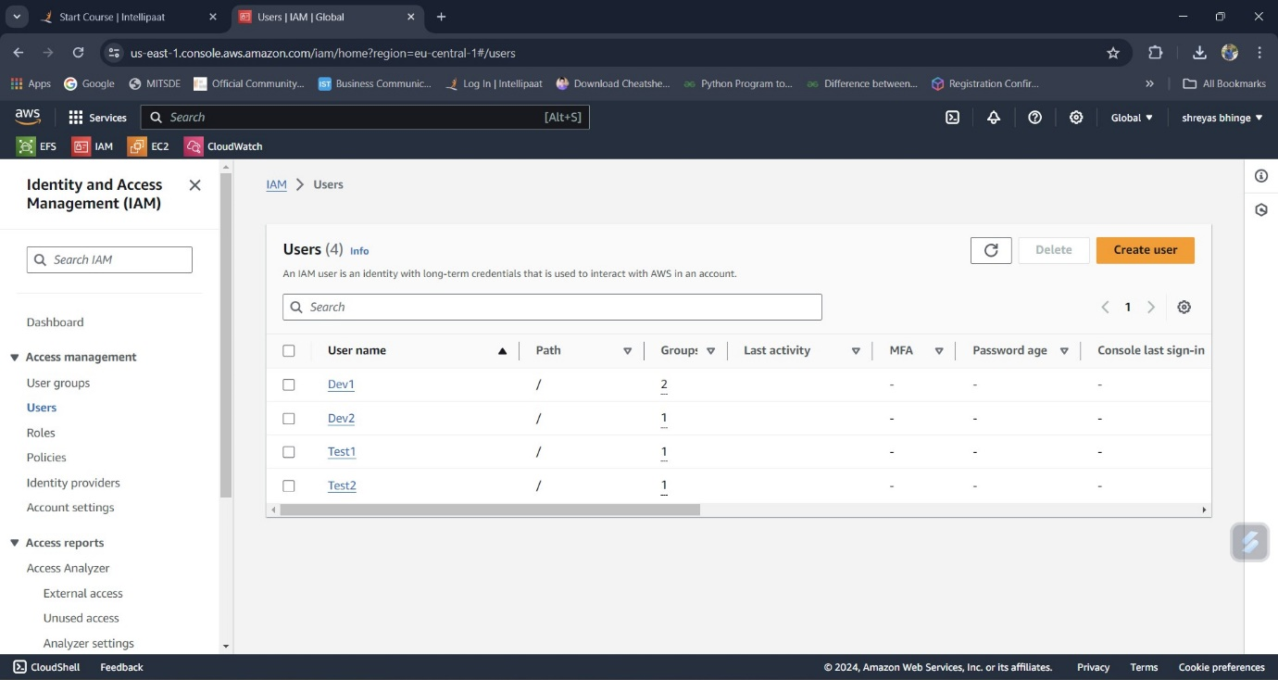

1. **Create 2 groups named “Dev Team” and “Ops Team”.**
2. Created 2 groups

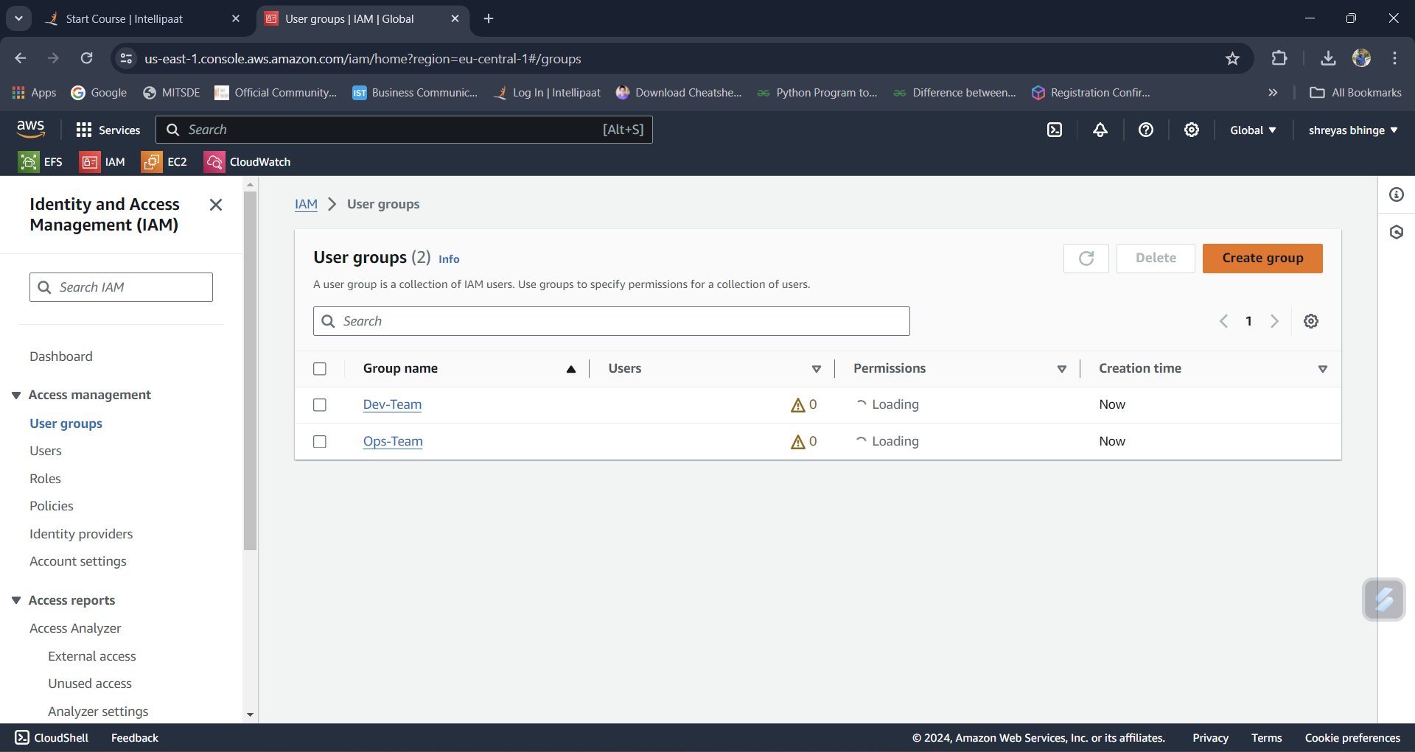

1. **Adding Dev1 and Dev2 to Dev-Team.**

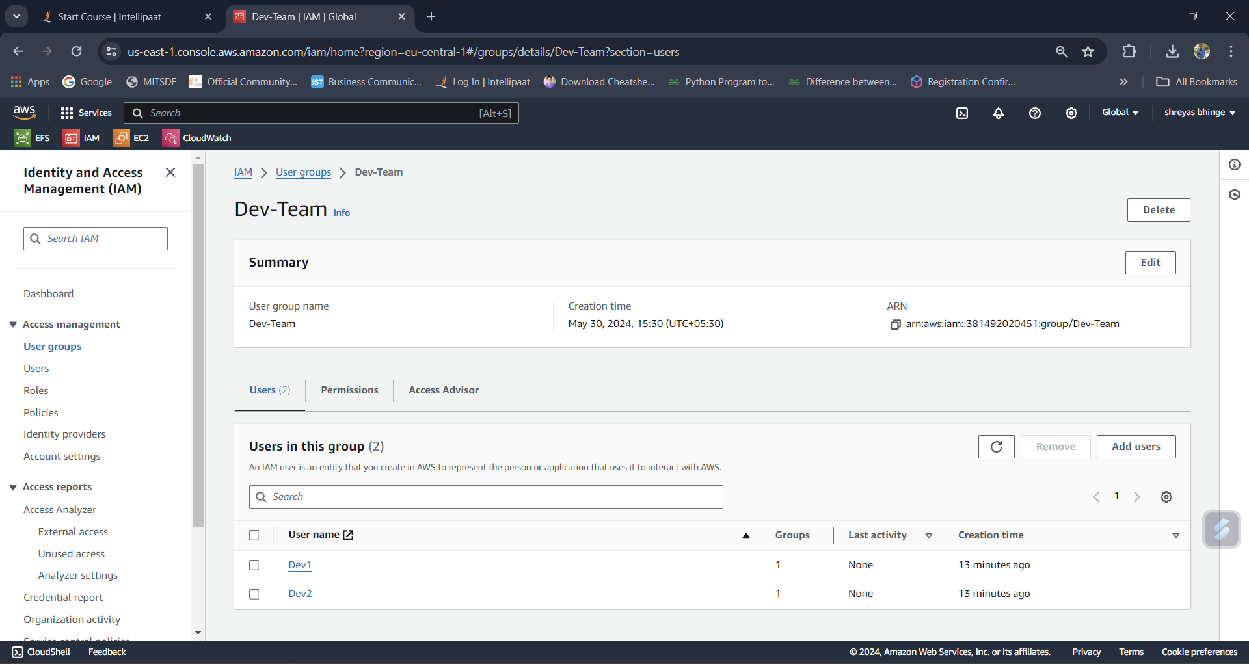

1. **Adding Dev1, Test1 and Test2 to Ops-Team.**

